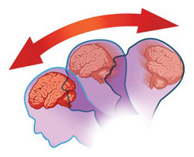

Customize this sheet with your Logo, and any school district or specific information.

CONCUSSION FACT SHEET ACKNOWLEDGEMENT

What is a concussion?
A concussion is a type of brain injury that changes the way the brain normally works. A concussion is caused by a bump, blow, or jolt to the head. Concussions can also occur from a blow to the body that causes the head and brain to move rapidly back and forth. Even what seems to be a mild bump to the head can be serious. Concussions can have a more serious effect on a young, developing brain and need to be addressed correctly.

What are the signs and symptoms of a concussion?
You can’t see a concussion. Signs and symptoms of concussion can show up right after an injury or may not appear or be noticed until hours or days after the injury. It is important to watch for changes in activity, behaviors, if symptoms are getting worse, or if s/he just “doesn’t feel right.” Most concussions occur without loss of consciousness.

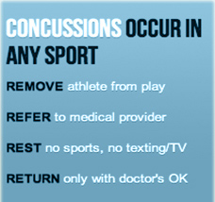
Please review the attached__________________ (Exact name of the Concussion Fact Sheet Provided to Student). For more information about concussions including the signs and symptoms. If you notice the symptoms, seek medical attention right away. Children and teens are among those at greatest risk for concussion.

Children and teens with a concussion should NEVER return to sports or recreation activities on the same day the injury occurred. They should delay returning to their activities until a healthcare professional experienced in evaluating for concussion says they are symptom-free and it’s OK to return to play. This means, until permitted, not returning to physical education (PE) class, sports practices or games, or physical activity at recess.

I understand that all concussions and concussion symptoms must be reported to the coach, teacher or athletic trainer right away. I have read and understand the above and have reviewed the concussion information sheet provided to me.

Signature Parent/Guardian Date

Student Name Student Signature

